Name: Amisha Farhana Shaik
Lab 2 Part 1: Dimensional Modeling Practice:
E1. UsedCarInc is a used car dealer. When a customer arrive with a car to sell, a dealer agent inspects the car and makes an offer to purchase the car. After purchasing, the car is cleaned and is made available for sale to other customers who come to buy used cars. Any dealer agent can be involved in either the purchase or sale process. Develop a dimensional model to support their main car purchase and sale process. A car purchase by dealer transaction includes information on the seller, dealer agent (employee), car, purchase price, and date. A car sale by dealer includes information on buyer, car, dealer agent (employee), sale price, and date. The company wants to increase profit (sale price minus purchase price) and have higher profit margins, and lower the number of days between car purchase by dealer and car sold by dealer (increase inventory turnover).
- What is the business process of interest here?
  - Car being purchased by dealer
  - Car being sold to customers by dealer

- What are the different levels of granularity present?
  - One care purchased by one agent at one date
  - One car sold to one customer by an agent on a particular date

- What are the dimensions for each grain identified in #2?
  - Seller dimension, employee dimension, car dimension and date dimension
  - Buyer dimension, car dimension, customer dimension, employee dimension and date dimension.

- What are the facts for each grain in #2?
  - Purchase price, inspection cost, maintenance cost, clean cost
  - Sales price, profit = sales price - Purchase price - inspection cost - maintenance cost - clean cost

- Specify if VIN Number and Mileage are included in the model and the most appropriate table where they can be included
Yes, they can be included in the car dimension.

- Would an accumulating fact table apply in this case?
Yes, milestone dates for purchase, inspection, maintenance, sale;
Some lags can also be calculated such as lags between sale and purchase.

E2. SunDucks coffee has coffee shops in multiple states. They sell coffee, snacks and related products. You have been provided the following dimensional model for Sales process of SunDucks Coffee, built for the granularity of 1 row per transaction. Identify (1) errors or issues with the model, (2) potential problems due to the errors and (3) propose revisions to correct the errors.
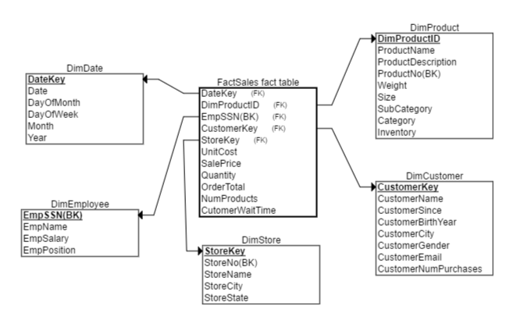
DimProduct
DimProductID | Primary key, sequentially generated
ProductName  ProductDescription | Name of product  Description of Product
ProductNo | Business Key
Weight | Product Weight
Size | Product size
SubCategory | Product Sub-cateogry
Category | Product category
Inventory | Number of product in company inventory
DimCustomer
CustomerKey | Primary key, sequentially generated
CustomerName | Name of Customer
CustomerSince | Date of first purchase
CustomerBirthYear | Year of Birth of customer
CustomerCity | Customer City of residence
CustomerGender | Customer gender
CustomerEmail | Customer email
CustomerNumPurchases | Number of purchases made by customer to date
DimStore
StoreKey | Primary key, sequentially generated
StoreNo | Business key
StoreName | Name of store
StoreCity | City in which store is located
StoreState | State in which store is located
DimEmployee
EmpSSN | Employee SSN, Primary Key, Business Key
EmpName | Name of Employee
EmpSalary | Salary of Employee
EmpPosition | Position of Employee
FactSales
UnitCost | Unit cost of product sold
SalePrice | Price at which product was sold
Quantity | Quantity of a product sold ( for e.g. two regular coffees)
OrderTotal | Total price of all products sold
NumProducts | Total number of products sold in order (for e.g. 3 products coffee, cookies and bottled water)
CustomerWaitTime | Total time waited by customer to receive all products in order

- Inventory cannot be in the product dimension.
Issue: Because whenever there are any changes in inventory, we need to update the product dimension. This type of update only reflects the latest data, we will lose historical values as well as dates.
Revision: We can create an additional periodical snapshot fact table storing the inventory balance per day of each product

- CustomerNumPurchases cannot be in the customer dimension.
Revision:
- Transactional fact table contain the quantity purchased for each customer. So we can use BI or analysis tool to aggregate the number of purchases in total to date during the analysis phase.
- Create another periodical snapshot daily for the total amount each customer purchased.

- Employee SSN is not appropriate for the usage as the primary key in the table.
Issue: Lose sensitive information, difficult to manage or retrieve the employee information
Revision: ETL system or DW system can automatically generate surrogate keys for employees

- Fact table has measurements at different levels of granularity
Issue: Unable to create such table in practice
Revision:
- Keep this table at the transaction level, then we need to remove all the measurements based on the product level.
- Convert the granularity of the table to product level.
order total = total amount paid for all the quantities
remove customer wait and number of products measurements

